Management Information Systems, 16E

Laudon & Laudon

Lecture Files by Barbara J. Ellestad

Chapter 2 Global E-Business and Collaboration

What would happen if you walked into work one day and management told the employees they could do anything, anything at all, that they wanted to do that day. If Jimmy from production decided he wanted to work in sales and marketing, he could. If Sally, who normally works in accounting, wanted to spend the day in shipping she could do that too. No one would have to follow any rules or any set procedures. They could accomplish the work any way they choose.

Sally decides that she doesn’t want to use FedEx to ship out the products that day even though the company has a contract, which saves them lots of money. She decides to use an alternate shipping service that will cost the company more and slow down the shipment significantly. She doesn’t see a need to tell accounting about the change.

Jimmy decides not to use the same old packing materials when he’s preparing glass bowls for movement across the country. He determines that it is faster if he just plops the bowls into a box, closes the lid, and sends it down the line. Unfortunately, his co-worker Tim (who doesn’t know anything about Jimmy’s decision) is responsible for answering customer complaints.

Bill in accounting decides that he needs a pay raise to help pay for his upcoming vacation. Normally, he would be required to get his supervisor’s approval to change any pay record but because there aren’t any established procedures he can just go ahead and enter the new salary data in the system. While he’s at it, he gives ten of his friends pay raises also. Although Bill’s friends may like the idea, the rest of the employees in the company are pretty upset.

2.1 What are business processes? How are they related to information systems?

As we discussed in Chapter 1, the “digital firm” means more than just plunking down computers that have all the latest bells and whistles on every desk. The digital firm must connect each functional area and each management level to one another. Data input to the system in manufacturing must be made available to sales, accounting, and shipping. Managers in the human resources department must have access to appropriate information regardless of its origin. Information integration is the key to the digital firm.

As we go through this chapter, we’ll look at the types of information systems organizations use to bring it all together. To help distinguish between the type of function each one is designed to accomplish and to fit them all together, we’re going to look at them in the context of manufacturing candy bars. Yep, candy bars. Everyone likes them and everyone has eaten one, so everyone can relate to them. We’ll call the company WorldWide Candy and we’ll give the candy bar the timely name of “Cybernuts.”

Business Processes

You can imagine from the above scenario how quickly chaos would reign in the organization without established business processes that integrate functions throughout an organization. Processes that deliver the best product for the lowest cost in the most efficient manner are imperative to success.

The way a business organizes its workflows, the method it uses to accomplish tasks, and the way it coordinates its activities among employees, customers, and suppliers determines its business processes.

Organizations, from the smallest one- or two-person group to the largest you can imagine, must have orderly processes that all divisions can understand. No part of the organization can work in isolation from any other part.

Table 2-1 describes some typical business processes for each of the functional areas of business. We will see later in the chapter how these businesses processes are supported by enterprise systems.

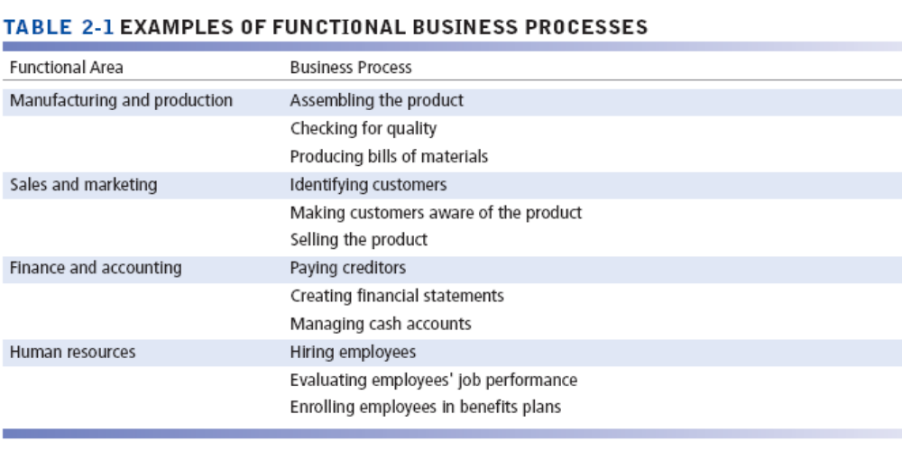

How Information Technology Improves Business Processes

Some processes that may have contributed to an organization’s success have now outgrown their usefulness. Information systems can help an organization recognize processes that may need to be changed. An information system could be used to automate some of those processes or to help managers determine that they are no longer needed. And a successful organization will use an information system to determine which processes are working well.

The key to using information systems to analyze, change, automate, or delete processes is that the organization must determine the appropriateness of the recommendations and must determine the right questions. Throwing a new-fangled computer system at the supposed problem is not the answer. And answering the wrong question with a good answer can be far more devastating to the bottom line than not doing anything at all. In other words, if the system says a process should be changed but it truly doesn’t make sense to change it, then don’t. The system should supply recommendations; humans still have the ultimate decision-making responsibility.

Information systems enhance business processes in two ways:
- Increasing the efficiency of existing processes by automating them.
- Enabling entirely new processes that are capable of transforming the business by changing the flow of information.

Bottom Line: Business processes help an organization organize, coordinate, and focus its workflow to produce products or services. The success or failure of a business may depend on how well its business processes are designed and coordinated. Information systems can automate many steps in business processes and even change the flow of information.

2.2 How do systems serve the different management groups in a business and how do systems that link the enterprise improve organizational performance?

There is no one single information system that will satisfy all of the needs of an organization. At first glance it can be difficult to comprehend all the different systems in a business, and even more difficult to understand how they relate to one another.

Systems for Different Management Groups

You’ll see at the end of this discussion the integral role each type of system plays—from determining which kind of candy bar to make (strategic level systems); to how many people the company will need to make the candy bar (management level systems); to tracking customer orders (operational level systems). Within these three levels we’ll discuss the four major types of systems typically used to make an organization successful.

Transaction Processing Systems

The operational level of an organization includes various units such as the order processing, material movement control, payroll, accounts payable, and employee record keeping. This level is responsible for daily operations. The information systems used in this level of the organization are transaction processing systems (TPS), so called because they record the routine transactions that take place in everyday operations. TPS combine data in various ways to fulfill the hundreds of information needs a company requires to be successful. The data are very detailed at this level. For instance, a TPS will record how many pounds of sugar are used in making our Cybernuts candy bar. It also records the time it takes from beginning to end to make the candy bar. And it can record the number of people working on the assembly line when our candy bar is made and what functions they perform.

People using transaction processing systems usually need information to help them answer routine questions such as: “How many Cybernuts candy bars did we produce yesterday?” or “How much sugar do we have on hand for today’s production run?”

However, there’s more to making the Cybernuts bar than just running the assembly line; a TPS will record the sales and marketing transactions as well. The system will record not just the number of dollars used in the marketing program, but also how many stores are actually stocking the candy bar and where the product is located inside the stores.

You have to remember that a lot of work is required to get the product from the manufacturing plant to the store shelves. How much did the company pay to package the product, store the product, and ship the candy bar to the stores? All that data can be recorded in a TPS, right down to how many truck drivers are required to deliver products to local convenience stores.

As you can visualize, the operational level of an organization also includes functions not directly associated with the actual production of the Cybernuts bar, but vital in keeping the company running smoothly. The people in accounting may not be pouring the chocolate over the nuts on the assembly line, but the workers that do appreciate receiving a paycheck every two weeks. Production workers also like to know that the human resources division is keeping track of training programs that may help them advance within the company. Each of these divisions requires an information system that helps it keep track of the many details that make the production worker happy and productive. The best transaction processing system will be integrated throughout the organization to supply useful information to those who need it when they need it.

Bottom Line: The transaction processing system records the data from everyday operations throughout every division or department in the organization. Each division/department is tied together through the TPS to provide useful information to management levels throughout the company.

Systems for Business Intelligence

Think about the functions of managers that you may have learned about in other classes: directing, controlling, communicating, planning, and decision making. Each manager takes on these roles countless times in a day. Managers review endless amounts of data that make their jobs easier and more efficient.

Businesses and organizations collect billions and billions of pieces of data on everything from customers to suppliers to business partners. Collecting the data is the easy part—almost too easy. Once the data are collected it’s much more difficult for managers and executives to actually use them to make smart decisions. That conundrum has given rise to business intelligence software applications that help users make sense of all that data. Decision makers can discern hidden patterns and trends in the data and use the information to the organization’s benefit.

Management information systems (MIS) are designed to produce information on a periodic basis instead of on a daily recurring basis such as those using a transaction processing system. Managers also require information on an exception basis. That is, they need to know if production is higher or lower than the targeted rate or if they are over or under their budgets. They also need to know about trends instead of straight numbers. The questions they may ask of the system would be: “How far behind in production are we for this quarter?” or “How many more workers would we need if we increased production by 10,000 candy bars per quarter?” or “If we do adopt the new Cybernuts recipe, what positions are open for the 25 excess workers and what skills do they possess that the company can use elsewhere?”

Before integrated systems, managers received periodic printed reports that gave them lots of data, but often didn’t supply information that they could utilize to make timely decisions. Planning was sometimes a wasted effort because the information the managers needed just wasn’t there when they needed it.

If there was a problem getting a shipment out to the convenience store in Paducah, Kentucky, the shipping manager may not have known about it until a customer cancelled her account six months later. The human resources department manager would likely not be able to find out about new job opportunities in a different part of the company until after the workers were laid off and had found other employment. Worse yet, production might have to stop the assembly lines because accounting hadn’t purchased enough supplies to cover the increase in the number of candy bars rolling off the line.

With the integration of information systems up and down the management levels, and throughout the corporation, managers can often get needed information in a real-time mode. The data are kept online, the system can gather the precise information managers need to make a decision, and the information can be cross integrated into all departments of the company. All divisions in the company can see what’s going on throughout the corporation. Information can be passed from department to department so that they are all working “on the same page.”

Bottom Line: A management information system is used by managers throughout the organization to help them in directing, planning, coordinating, communicating, and decision making. The MIS will help answer structured questions on a periodic basis.

Decision-support systems (DSS) also serve the management level of an organization, but in a somewhat different way from an MIS. An MIS uses internal data to supply useful information. A DSS uses internal data but also combines it with external data to help analyze various decisions management must make. Analyzing complex, interactive decisions is the primary reason for a company to use a DSS.

The sales and marketing management of WorldWide Candy would use a DSS to answer a semistructured question such as: “What price should we charge for the Cybernuts candy bar so that we can maximize our profits, minimize our costs, and still remain competitive?” Using a DSS, the manager in charge of the manufacturing division could determine the best answer to this semistructured question: “How does the change in the size and packaging of the Cybernuts candy bar affect the other products we produce, not just in shipping, but also on the display shelf at the convenience store?”

You’ll notice we describe decisions at this level as semistructured. Not all decisions required for an organization to function smoothly are cut-and-dried. There are a lot of gray areas in successfully managing an organization and the larger the company, the more diverse the decision-making process becomes.

A company is affected not only by what goes on solely within the company, but also by external forces not under its control. Decision-support systems can help upper-level management negotiate these forces. What happens to the pricing structure and availability of the raw materials for the Cybernuts bar if civil war breaks out in the sugar producing countries of Central America? The price of electricity can greatly affect the profit and loss of the Cybernuts bar. Fluctuating gasoline prices affect the profit margins by increasing or decreasing the distribution costs of the product. All these external events can be put into context in a decision-support system so that WorldWide’s management can make effective decisions.

Bottom line: Decision-support systems are used for complex “what-if” questions that require internal and external data. Decisions at this management level are mostly semistructured so the information system must respond to the unique requirements of the executives.

Executive support systems (ESS) are used at the very upper echelons of management. At the strategic level, the typical decision is very unstructured. Often there is no specific question, but rather a series of undefined situations executives may face. There are no easy, definable answers. These executives require summarized, historical information gleaned from all other levels of the organization, coupled with large amounts of external data gathered from many sources.

Let’s assume that the Cybernuts bar is the most successful, most popular candy bar ever made. (You could say its success is due to the effective use of the previous three information systems!) The Universal Food Products Corporation just can’t create a product that comes close to the success of Cybernuts (their information systems aren’t as good) and is very envious of WorldWide Candy. So Universal Food Products offers to buy the Cybernuts product from WorldWide for what seems to be an astronomical amount of money. WorldWide executives can use their executive support system to determine if this offer is in the best interest of all. They can analyze the information gathered from all of the internal information systems and couple that with external data to help them make the decision. With an ESS, company executives can make their decision based on information, not on emotion.

Senior executives often access information through the use of a portal. Basically, a portal is a web interface designed to present integrated personalized business content from a variety of sources.

Interactive Session: People: Data Changes How NFL Teams Play the Game and How Fans See It (see p. 5 of the textbook) discusses how an organization uses various forms of information systems like transaction processing systems and decision support systems to improve how its players and teams perform and how fans experience the game.

So that executives who haven’t been using computers that long and don’t have time to fiddle around learning how to type, executive support systems use digital dashboards to make the system easy to use and provide information in a real-time mode. The ESS must be able to incorporate external information with internal data to offer concise, complete information for the imprecise and incomplete scenarios executives face.

Bottom Line: An executive support system helps managers make strategic decisions affecting the entire company. The decisions use internal and external data to give executives the information they need to determine the proper course of action in unstructured situations.

Systems for Linking the Enterprise

It’s not unusual to find an organization with three or more different information systems that act as islands. The systems don’t exchange information very well, if at all. Accounting and finance may have a system that serves their needs very well, but they can’t collect information from the system used by manufacturing and production. Sales and marketing is doing its own thing with another system and losing valuable information from the other systems, which could help it do a better job.

Enterprise Applications

No business can afford disjointed information systems that don’t work together to produce a coherent picture of the entire organization. All the functions of a business must be integrated across traditional lines of demarcation. Islands of information can be devastating to a company if data cannot be shared throughout the company. Even worse, the islands of information can create problems if each faction of an enterprise has differing information that conflicts with other islands of information. These kinds of problems are what gave rise to enterprise applications that share the same data anywhere it’s needed in an organization. As networks of all kinds take hold, from the Internet to intranets to extranets, web-based enterprise applications are increasingly widespread.

The following sections are an overview of four major enterprise applications: enterprise, supply chain management, customer relationship management, and knowledge management systems. We’ll also study each of these systems in depth in future chapters.

Enterprise systems (also known as enterprise resource planning (ERP) systems) are used to bridge the communication gap among all departments and all users of information within a company. If the WorldWide Candy Company production department enters information about its processes, the data are available to accounting, sales, and human resources. If sales and marketing is planning a new advertising campaign for the Cybernuts candy bar, anyone anywhere within the organization will have access to that information. Enterprise systems truly allow a company to use information as a vital resource and enhance the bottom line.

The greatest enticement of enterprise systems is the chance to cut costs firm-wide and enhance the ability to pass information throughout the organization. The biggest drawbacks to building enterprise information systems are time, money, and people. Because the installation of the system is so invasive, it takes a tremendous amount of time to install the hardware and software, train people to use it, and rework business processes that will then inevitably change. Many companies find it more trouble than they care to handle.

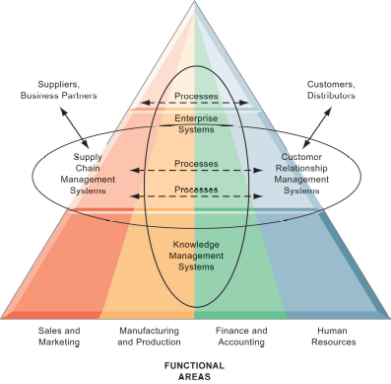
Figure 2.6: Enterprise Application Architecture

Even if you properly manage your processes, wring out excess costs from every corner of the organization, and above all, have the best products at the lowest cost, if you can’t get your products to the right customers at the right time what good is all the rest? Managing your supply chain and getting products or services to customers efficiently and effectively is the real key to success.

Supply chain management systems offer new opportunities for companies to integrate data and information with their suppliers and customers and ultimately, lower costs for everyone. When WorldWide Candy installed their supply chain management system, a form of interorganizational systems, they created a cohesive network for buying raw materials, creating the candy bars, and getting the packaged goods to retail outlets.

Do you wait for the customer to complain about your poor service before you take a critical look at your business processes? Do you spend more time and money acquiring new customers than you do in keeping your existing ones? Does each functional area of your organization have a completely different and separate viewpoint of your customers? Does your sales and marketing department make promises to your customers that manufacturing and production can’t possibly keep? If you answered yes to one or more of these questions, you’re in serious need of a good customer relationship management (CRM) system.

CRM technology isn’t just a nice looking web site for customers to click through or more reports dumped on managers’ desks that they don’t have time to review. CRM systems involve business processes in all the functional areas and every management level of a firm. The ideal CRM system provides end-to-end customer care from receipt of order through product delivery.

Because of technological limitations in the past, many companies created islands of information in the various functional areas. Sales and marketing at Cybernuts may tell a customer that the product order would ship by the fifteenth. Meanwhile manufacturing and production was experiencing a delay in producing the Cybernuts candy bar because the finance department didn’t purchase enough raw goods. The islands of information prevented each functional area from knowing the situations in other areas. CRM systems help solve some of these disjointed snafus.

CRM also helps a firm cut the costs of keeping good customers by supplying the entire organization with a consolidated view of the customers’ needs. Unprofitable customers are more easily identified with a CRM system and the time and energy spent can be retargeted to more profitable customers.

You may not think of a knowledge management system as an integral part of the overall information system of an organization. In the 70 year history of digital information systems, Knowledge management systems (KMS) are relatively new, first appearing in the last three decades. KMS enable organizations to better capture, manage and apply employee and organizational knowledge and expertise.

Knowledge workers are those who promote the creation of new knowledge and integrate it into the organization. Research scientists may discover new methods of mixing sugar and cocoa beans and dairy products to make a better chocolate. Maybe a team of engineers will develop a new method of packaging the Cybernuts bar to make it easier to open. The legal knowledge workers may spend their time determining the copyright protections that could be afforded to the Cybernuts product name.

Intranets and Extranets

Enterprise applications are often costly to implement. Companies that don’t have the resources to invest in enterprise applications can still achieve some measure of information integration by using intranets and extranets.

Intranets and extranets use Internet technology and standards to assemble information from various systems and present it to the user in a web page format. Extranets make portions of private corporate intranets available to outsiders.

Both of these tools make it easy for companies to disseminate information through a standard platform that requires very little work to maintain. It’s a low-cost way to connect internal employees with one another or external users to company information.

E-Business, E-Commerce, and E-Government

The Internet, extranets, and intranets offer new opportunities to do business in cyberspace. The amount of electronic commerce and electronic business conducted online continues to grow exponentially year after year without any signs of slowing down. The two terms e-commerce and e-business are often confused with each other.
E-commerce is limited to the buying and selling of goods and services on networks.
E-business encompasses not only e-commerce but a broader range of tasks like coordinating training seminars for customers.

Even with the rising popularity of these new ways of doing business, you should take caution. It’s easy to put up a snazzy, colorful web site that looks very pretty and may even be easy to use. It may be a site on the Internet, an intranet, or an extranet. You must consider though, how you’re going to incorporate that part of your business with your other, more established methods of doing business. What internal processes must you change or adapt? What new processes must you establish? What training must you do with the people who will run the e-business, both technical and nontechnical? You can’t keep doing your job the same old way. Lots of businesses have tried and lots of businesses have lost big bucks.

The electronic delivery of government services via the Internet has been fairly successful. Citizens have easy access to forms necessary in many e-government programs such as tax payments. Rather than waste time standing in line for vehicle registration and licenses, people can complete these kinds of tasks on the Internet. Perhaps most importantly, e-government has opened the lines of communications between citizens and elected officials and made information access easier and timelier.

Bottom Line: Integrating functions and business processes cut costs and allow systems development that involves the whole firm or industry. Customer resource management and supply chain management give a company the added advantages of end-to-end customer care. Enterprise systems have many challenges but the benefits, when executed properly, are enormous. Knowledge management systems allow an organization to fully integrate their newly acquired knowledge into the current systems.

2.3 Why are systems for collaboration and social business so important and what technologies do they use?

Globalization now allows companies to work around the clock, around the world. It’s not unusual for major corporations to shift work from one time zone to another, one country to another. Somehow, the people in all the geographically-separated locations have to be able to easily communicate and share information with one another. Working in teams is now becoming the de facto practice in the business world.

What Is Collaboration?

Let’s first determine exactly what the term collaboration means to businesses and to you:

- Working with others to achieve shared and explicit goals
- Focusing on a particular task or mission
- Ocurring in a business and/or between businesses

Collaboration can be:
- Short or long term
- One-to-one or many-to-many
- Informal or structured teams

Collaboration and teamwork have grown in popularity over the last few years because new technology has made it much easier for people to communicate and share information, files, and documents. Imagine how difficult it would be to collaborate with a colleague across the country if you had to pass documents back and forth using snail-mail.

Collaboration and teamwork are central to the success of many businesses. Here are six reasons why businesses promote collaboration and teamwork:

- Changing nature of work—traditionally work was organized into silos. Now, most new jobs require interaction among employees, suppliers, and customers.
- Growth of professional work—most professional jobs require close coordination and sharing information and opinions with other professionals.
- Changing organization of the firm—traditionally organizations used a managerial hierarchy. Now, many firms have been “flattened” and expertise and decision-making powers are pushed down to groups and teams.
- Changing scope of the firm—globalization has created organizations that are disbursed to many geographically separated locations that require close coordination.
- Emphasis on innovation—innovation comes more from teams and groups than from a single individual. Collaborative practices and technologies increase the likely success of innovation.
- Changing culture of work and business—diverse teams tend to produce better outputs and do it faster than individuals.

What Is Social Business?

Collaboration among employees, suppliers, and customers is becoming an important tool in increasing a company’s competitive advantage. Social networking platforms such as Facebook, Twitter, and Pinterest help improve a company’s social business to establish and improve interactions with groups inside and outside the organization. Information sharing, innovation, and decision making are enhanced through these technologies.

Communications among managers, executives, and employees can be improved and streamlined through the use of social business. Table 2.2 provides a list of social business applications and their descriptions.

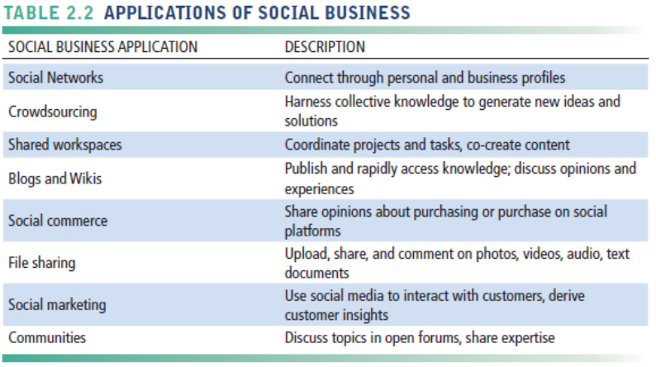

Business Benefits of Collaboration and Social Business

Many major corporations are embracing collaboration and teamwork not just within their own company, but with people outside the organizations.

“IBM is prowling the world to set up what it calls ‘collaboratories’ which match up its researchers with experts from governments, universities, and companies. IBM is trying to convince countries and companies that it can help them improve their ability to innovate at an important moment for the global economy. In recent years, companies such as Hewlett-Packard and Intel have begun tapping talent from outside for essential bits of science and technology—a concept called open innovation. Now IBM is moving a giant step further by making collaboration with outsiders an essential piece of its research strategy. The depth of that collaboration, the number of partners, the staff involved, and its global reach set IBM apart. ‘To move in this direction, you have to be willing to not just take risks but be open to accepting ideas from around the world,’ says Soumitra Dutta, professor of business and technology at Europe’s INSEAD.” (BusinessWeek, Big Blue’s Global Lab, Steve Hamm, Sep 7, 2009.)

Table 2.3 emphasizes the benefits of collaboration and social business: increased productivity, increased quality of work, more and better innovation, improved customer service, and increased profitability, sales, and sales growth. Figure 2.7 highlights the necessity of having the appropriate organizations structure and culture, along with the right technology.

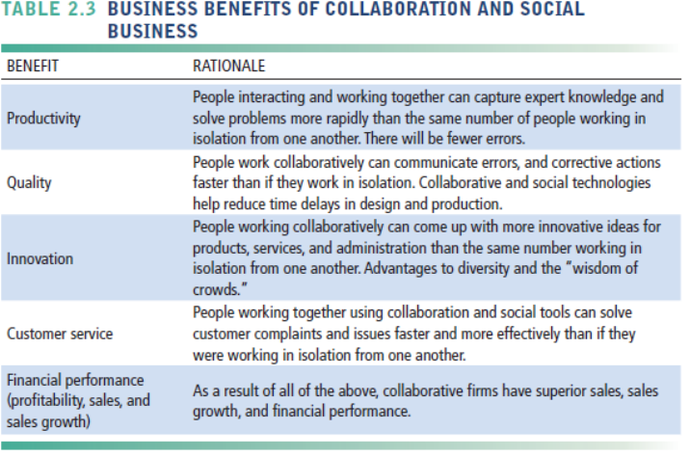

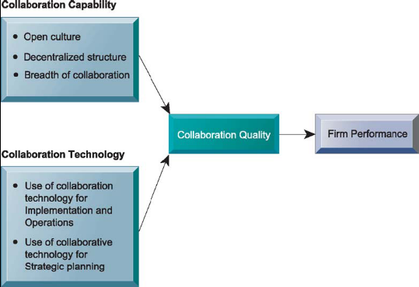

Figure 2.7 Requirements for Collaboration

Building a Collaborative Culture and Business Processes

Trying to mesh a typical hierarchical management structure with a true collaborative environment simply won’t work for one major reason. In a hierarchical organization structure, communications are passed up the management ladder from employees, across to another management ladder and back down to employees. That’s extremely slow, cumbersome, and has an awful lot of “filters” as messages are passed from one person to another.

Collaboration and teamwork require much faster communications and information sharing. In essence it requires managers to set specific goals and then “get out of the way.” Teams develop products, design new ideas or processes, and create new systems and technologies. Individuals are rewarded based on the success of the team rather than their own individual merits. Managers build the teams, coordinate the work, and monitor performance.

But in order for all this to work well, an organization must have the right tools and technologies in place.

Tools and Technologies for Collaboration and Social Business

Many new systems for interacting with other employees, managers, vendors, and customers have been developed. You probably use some of them without realizing how essential they’ve become in creating an environment that supports a collaborative culture.

- E-mail and instant messaging: billions of messages flow everyday among employees, managers, suppliers, and customers.
- Wikis: gaining in popularity as a way to share knowledge and ideas among collaborators. They are much easier to use and manage than more sophisticated knowledge management systems.
- Virtual worlds: able to house online meetings, training sessions, and lounges, this type of tool is gaining popularity as a way to meet, interact, and exchange ideas.

Collaboration and Social Business Platforms: Let’s assume you are part of a team working on a new candy product for WorldWide Candy Corporation. You work in Atlanta, Georgia, while your teammates work in New York City, Seattle, and Dallas. Sure, you could all fly to a central meeting place once a month to collaborate on the new candy bar. But imagine how cumbersome and slow that would be. Not to mention expensive and time-consuming.

Virtual Meeting Systems: With a virtual meeting system, you can hold strategy sessions once or twice a week instead. You would feel like all of your teammates are physically located in the same place if you use telepresence technology. You can share ideas and documents in real-time. Best of all, you don’t have all the travel hassles and you can sleep in your own bed.

Interactive Session: Technology: Videoconferencing: Something for Everyone (see page 62 of the text) describes the progress companies have made in building new technologies that enhance videoconferencing and make it less expensive to use. It’s also becoming a driver in how businesses can work more globally.

Cloud Collaboration Services: While your WorldWide Candy team is collaborating on the new candy bar, you’ll find it necessary to share word documents, spreadsheets, calendars, and perhaps audio and video files. Rather than create the online structure for all this, not to mention spending big dollars, your team can use Google Tools that include Google Drive, Google Docs, Google Apps, Google Sites and Google + to easily set up the necessary technology infrastructure you need. You’ll have the benefit of e-mail, instant messaging, and threaded discussion, so all of you can communicate in real-time. You’re also able to save and archive all your communications for future reference. You can’t necessarily do that in a face-to-face meeting.

Microsoft SharePoint and IBM Notes: WorldWide Candy already uses Microsoft servers and networking products, along with the Microsoft Office suite of Word, Excel, Outlook, and PowerPoint. Your team can use all of these as a base for collaboration by developing a web site that organizes and stores information in one location. The host web site provides the following benefits:
- Coordinate work activities
- Collaborate on and publish documents
- Maintain task lists
- Implement workflows
- Share information via wikis and blogs

Another Internet-based collaboration environment your team could use is IBM Notes. It provides all the basic collaboration tools as Google Apps/Google Sites and SharePoint do but with a few added features. It has social networking enhancements and the ability for your team to develop its own custom applications. The most beneficial feature of IBM Notes for very large corporations is the higher levels of security and reliability along with the ability to keep control over sensitive information.

Enterprise Social Networking Tools: These tools, such as Jive and Yammer, help connect an organization’s members through profiles, updates, and notifications but are restricted to internal corporate uses. Some include user profiles, communities, e-mail, instant messaging, web meetings, calendars, personal dashboards, and file-sharing.

Checklist for Managers: Evaluating and Selecting Collaboration and Social Software Tools

Sometimes the decision about which of these tools to use may be up to you. How do you decide which one is best? Figure 2.8 gives you a matrix that will help you sort through all the hype and make a decision based on your needs. The matrix uses two dimensions, time and space, to compare the tasks you want to accomplish with the best way to do so. For instance, will your team use synchronous (same time) or asynchronous (different time) to meet? Mostly, you need to analyze the collaboration tools from a cost-benefit point of view.

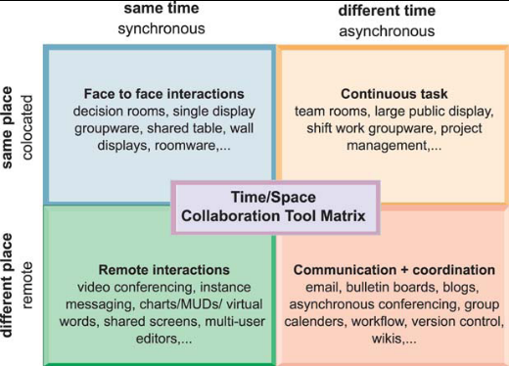

Figure 2.8 The Time/Space Collaboration and Social Tool Matrix

You can also use these six steps to help you select the best product for the task at hand:

- What are my challenges in terms of time and space?
- What solutions are available for each of the challenges?
- What are the costs and benefits of each solution?
- What security risks and vulnerabilities are associated with each solution?
- What are the implementation and training issues associated with each solution?
- Choose the collaboration tools and seek presentations from the vendors

Bottom Line: Collaboration and teamwork is the name of the game in today’s corporate world. There are many different tools and technologies that help enable collaboration. The firm must have a collaborative culture that encourages employees to work together as a team to ensure success.

2.4 What is the role of the information systems function in a business?

Many people focus on the job losses caused by technological advances and changes. On the other hand, many new jobs have been created because of technology. Information systems departments, previously a tiny group of people usually assigned to the financial group, have moved into the mainstream of most companies.

The Information Systems Department

Programmers have taken on more important positions within organizations. They must understand not only the technical side of computing, but they must also know business processes so they can adapt the technology to the needs of their company. Systems analysts serve as the bridge between the techies and the nontechies. Heading this group of people are the information systems managers. Their importance to businesses has grown as the emphasis on technology’s role within organizations has grown.

Just as most organizations have a chief financial officer, the position of chief information officer has been created to handle the myriad of problems and opportunities businesses face in today’s technologically driven environment. Very large corporations appoint a chief security officer who’s responsible for enforcing the firm’s information security policy and training users and information systems technologists about security. The CSO keeps other executives and managers aware of security threats and maintains security tools and policies.

The chief privacy officer protects an organization’s data from misuse and abuse and makes sure the company complies with data privacy laws. Another new position, that of chief knowledge officer, has been created in larger corporations to deal with effectively using knowledge management systems.

Some major corporations are establishing a position for a chief data officer who is responsible for enterprise-wide governance and utilization of information that is gleaned from all the data an organization collects and stores. Making sure the company is collecting appropriate data, analyzing the data properly and using the results to support good business decisions is the CDO’s main responsibility.

Perhaps the most important role of all, though, is the end user. The responsibility for successful integration of information systems has extended past the “techies” and become part of everyone’s job. As we’ve seen so far, no functional area or level of organizational hierarchy is exempt from understanding information systems and how they can help businesses meet their objectives.

Organizing the Information Systems Function

Deciding how to organize the information systems function within a business is not as easy as deciding how to organize other functional areas. After all, sales and marketing has a much different mission than production and manufacturing. An information system on the other hand has similar tasks regardless of the functional area it is supporting. Sales and marketing needs access to data the same as production and manufacturing.

Larger companies and organizations develop an IT governance that helps decide the best way to organize the IT department for the benefit of all. Some of the issues to be decided upon are:
- Strategy and policies for using IT
- Accountability toward the organization’s strategies and objectives
- How much centralization will take place within the IT function
- Does the organization receive a positive return on its IT investments?

Bottom Line: The IS department is an integral part of any successful business. Programmers, analysts, IS managers, and the CIO are major players in the IS function. Large corporations use a chief security officer, chief privacy officer, and a chief knowledge officer to ensure investments in information technology pay big dividends to the firm. The most important role in effectively using technology belongs to the users.

2.5 How will MIS help my career?

The chapter’s elements and information can help in securing a good job as a sales support specialist. This position will provide overall systems, administrative, and data management support to the national sales organization for a company’s division that markets to small businesses. These types of jobs are becoming more popular as information technology becomes more important in the workplace.

Discussion Questions:

- How can a transaction processing system help an organization’s management information system and decision-support system?

- Which of the four major types of information systems do you think is the most valuable to an organization?

- Discuss the benefits and challenges of enterprise systems and explain why a firm would want to build one.

- Discuss why a typical hierarchical management structure is not conducive to a collaborative business culture.

- Discuss the tools and technologies for collaboration and social business that are available and how they provide value to an organization.

Answers to Discussion Questions:

- A transaction processing system gathers data about the day-to-day operations of the organization from all functional areas. The data can be fed into the other systems to help the business meet its objectives. It can also help prevent islands of information in the organization.

- Opinions will vary about which type of information system is the most valuable. Answers should include information about why the student thinks the one they have chosen is most valuable. For instance, some students may claim that a TPS is the most important because it collects data which become the foundation for all other systems. Other students may determine that DSS are more important than the others because these systems increase the viability of decisions that may affect large parts of the organization.

- Benefits of an enterprise system include a consolidated view of the organization, unified platforms, more efficient operations, and customer-driven business processes. Challenges include daunting implementation, high up-front costs, unpredictable future benefits, inflexibility, and difficulty in realizing strategic values in the company. Organizations are enticed to build enterprise systems because they offer enormous cost savings in the long run, increased efficiencies in business processes, and give the firm an advantage over its competitors.

- Business firms, especially large firms, had in the past a reputation for being “command and control” organizations where the top leaders thought up all the really important matters, and then ordered lower level employees to execute senior management plans. The job of middle management supposedly was to pass messages back and forth, up and down the hierarchy. A collaborative business culture is very different. Senior managers are responsible for achieving results, but rely on teams of employees to achieve and implement the results. Policies, products, designs, processes, and systems are much more dependent on teams at all levels of the organization to devise, to create, and to build. Teams are rewarded for their performance, and individuals are rewarded for their performance in a team. The function of middle managers is to build the teams, coordinate their work, and monitor their performance.

- The tools and technologies for collaboration and social business include e-mail, social networking, wikis, and virtual worlds. Social networking sites give corporations another way for users to share ideas and collaborate with each other. Businesses can use them as a way to communicate with and reach out to customers. If done correctly, they can be a great tool to sell products, service customers, and communicate with the masses. Wikis are specially created web sites that provide a way for users to contribute and edit text content and graphics about a wide-ranging assortment of topics. They are generally less costly than formal knowledge management systems and may be more dynamic and current. Businesses can use virtual worlds to house online meetings, training sessions, and lounges for employees to communicate with one another.

